1. Exercise 1 (practice on SQL commands)

a. Practice all the following DDL commands

1. Creating a table



2. Altering a table

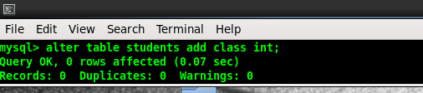

3. Drop a table

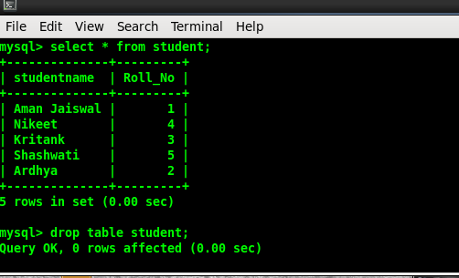

4. Truncating a table

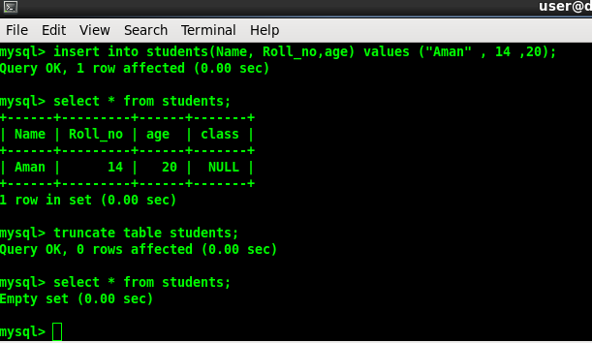

5.Rename

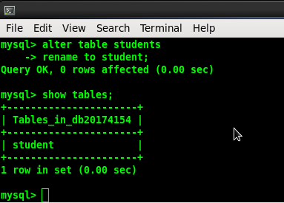

b. Practice all the following DML commands

1. Inserting Rows into table

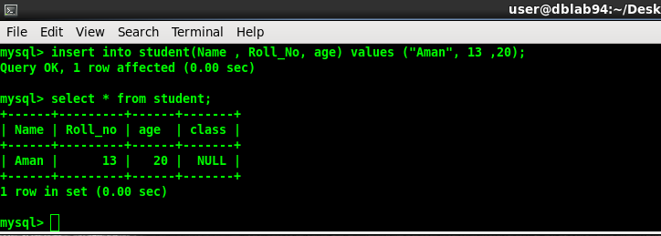

2. Deleting Rows from table

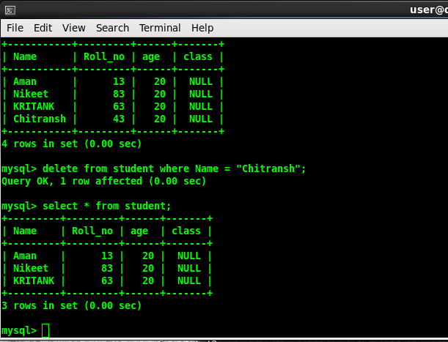

3.Updating data in a table

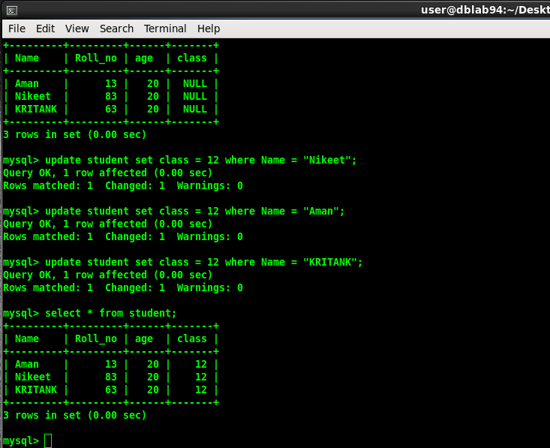

4. Defining constraints

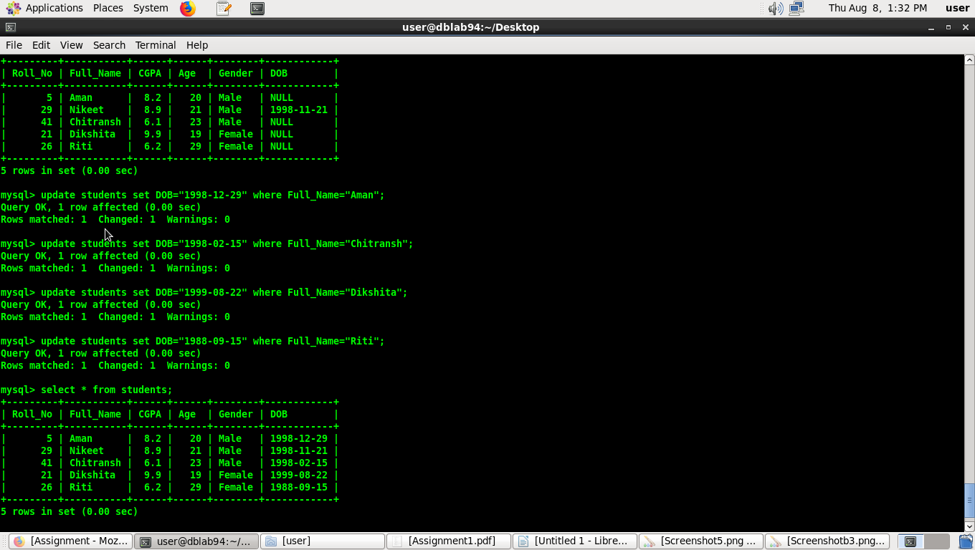

2.

Assignment on DDL and DML commands

A. Suppose that a faculty wants to keep records about the students, the desired records should maintain this

information about each student: (Roll No, Full name, CGPA, Age, and Gender)

a. Create the appropriate Table.

b. Write SQL Queries to answer the following problems:

- List the names of all female students.

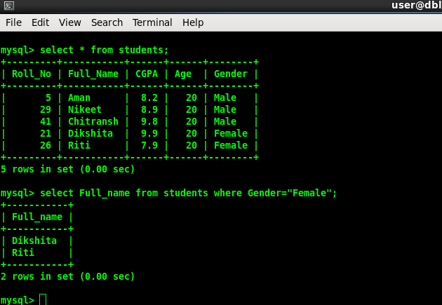

- What is the age of the youngest male student?

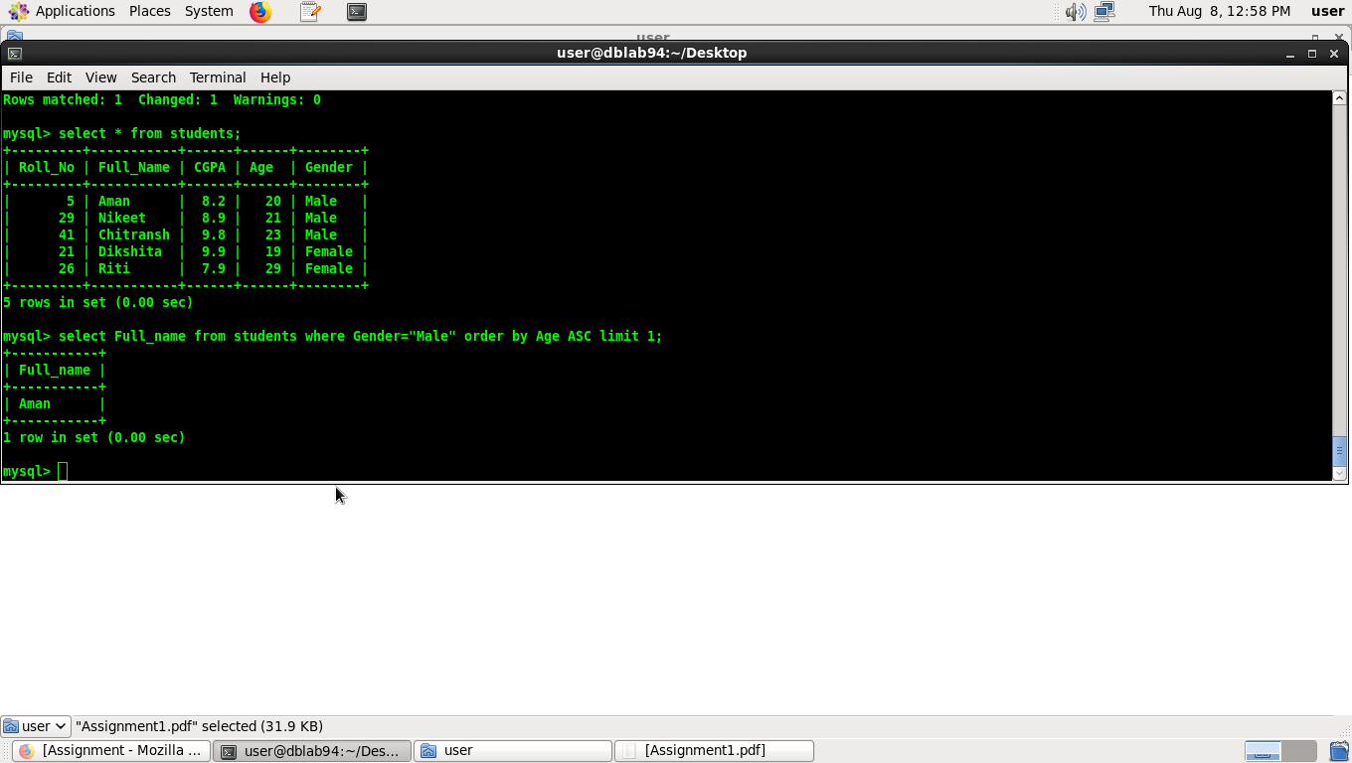

-

List the name and the CGPA for all students who got above 6.5 CGPA ordered by their

CGPAs then their names.

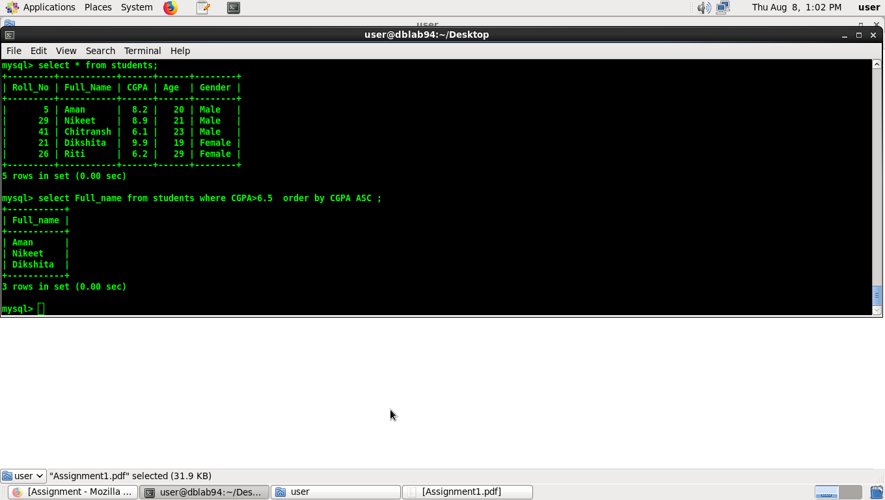

- What is the Topper name?

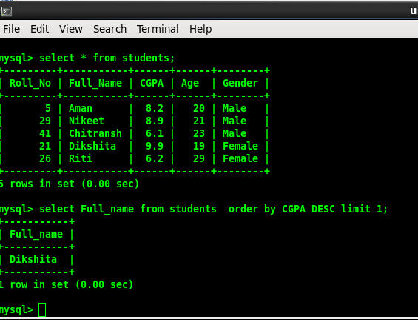

c. Since keeping the age of the student as an attribute requires frequent changes (each year) propose a solution and implement it.



3) A supermarket manager likes to keep records about all the items in his store these records should hold the

following information about each item (the item identifier item_id, the item name, the item price,

expiration date of the item, quantity in hand)

1. Create the appropriate table.

Create table supermarket (item_id int, name varchar(225), quantity int, expiry date);

insert into supermarket (item_id, name, price, quantity, expiry) values (1,"car", 2000012, 5, "2020-03-12");

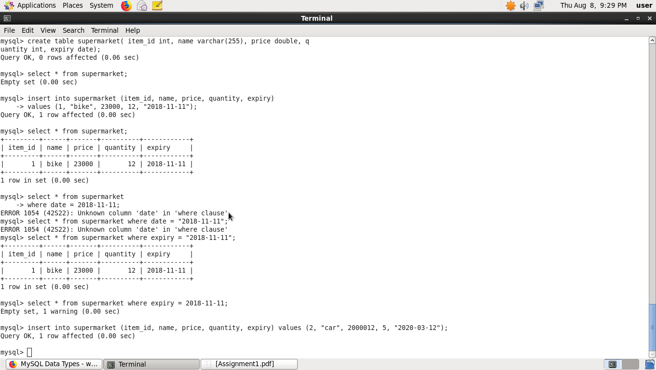

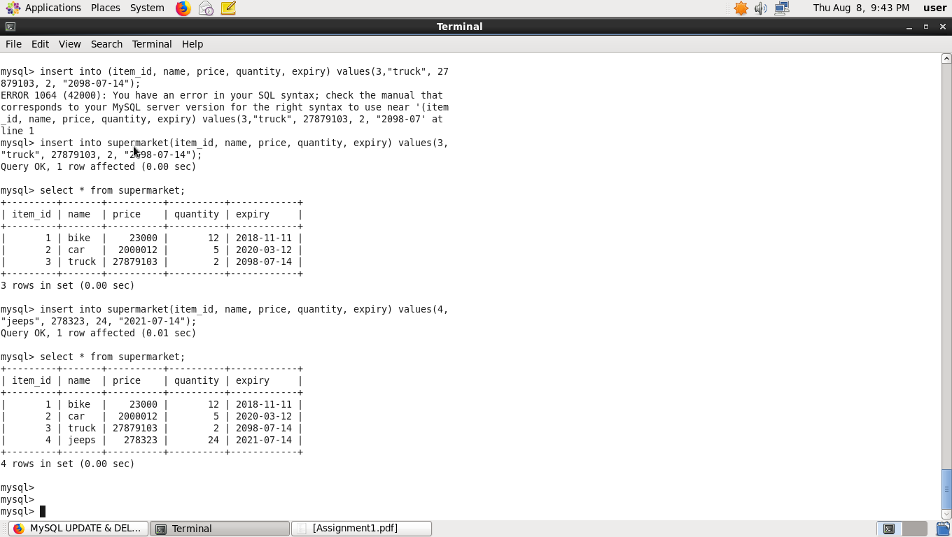

2. Write sql queries to answer the following problems:

- List the names and prices for all items that have a quantity in hand >20.

select name, price from supermarket where quantity > 20;

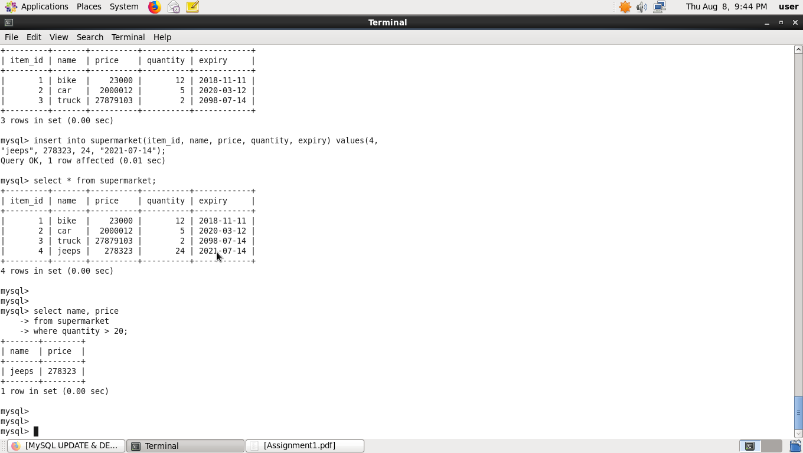

- List the names of expired items.

select name, expiry from supermarket where expiry < "2019-08-07";

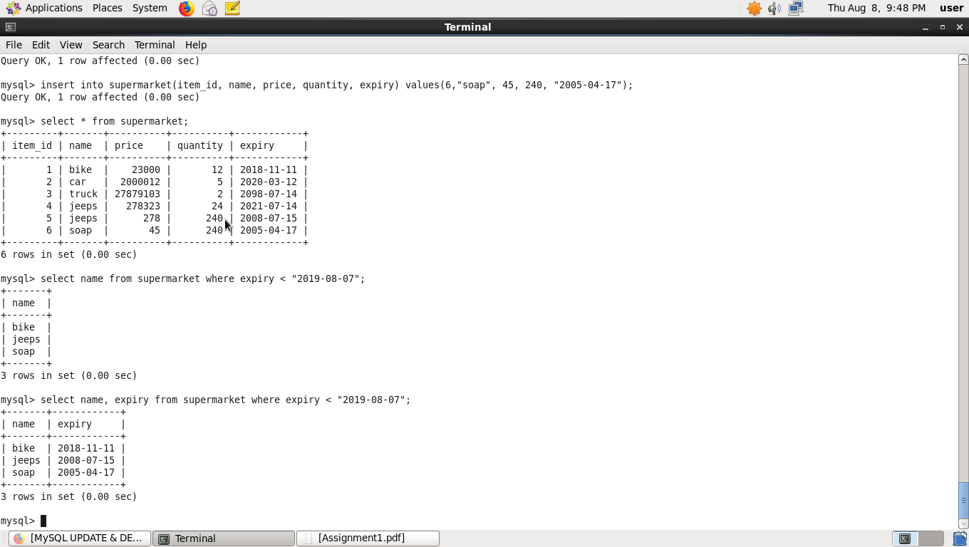

- name the second most expensive item.

select * from supermarket order by price DESC limit 1,1;

